AI Tutorial

IMP Links

* <https://colab.research.google.com/github/tensorflow/docs/blob/master/site/en/tutorials/quickstart/beginner.ipynb#scrollTo=he5u_okAYS4a>
* <https://www.tensorflow.org/lite/guide/hosted_models> (All Tensor Flow Models)
* <https://www.tensorflow.org/lite/examples> (Examples of Tensorflow Models)
* <https://www.tensorflow.org/lite/guide> (Starting guide for Tensorflow Model Development)
* https://www.tensorflow.org/lite/guide/android (Guide for Tensorflow Model Development on Android)
* <https://www.tensorflow.org/lite>
* [Intro to TensorFlow for Deep Learning - Udacity](https://classroom.udacity.com/courses/ud187/lessons/7b590cdb-0acf-4118-848c-8728ced19bc6/concepts/4e1b5f7e-5094-481e-ae29-284bc2fb847f) (Crash Course for beginners to learn Deep Learning) – added on 04-05-2022
* TensorFlow Lite is a set of tools that enables on-device machine learning by helping developers run their models on mobile, embedded, and edge devices.

**Development workflow**

### **1. Generate a TensorFlow Lite model**

A TensorFlow Lite model is represented in a special efficient portable format known as [FlatBuffers](https://google.github.io/flatbuffers/). This provides several advantages over TensorFlow's protocol buffer model format such as reduced size (small code footprint) and faster inference (data is directly accessed without an extra parsing/unpacking step) that enables TensorFlow Lite to execute efficiently on devices with limited compute and memory resources.

You can generate a TensorFlow Lite model in the following ways:

* **Use an existing TensorFlow Lite model:** Refer to [TensorFlow Lite Examples](https://www.tensorflow.org/lite/examples) to pick an existing model. Models may or may not contain metadata.
* **Create a TensorFlow Lite model:** Use the [TensorFlow Lite Model Maker](https://www.tensorflow.org/lite/guide/model_maker) to create a model with your own custom dataset. By default, all models contain metadata.
* **Convert a TensorFlow model into a TensorFlow Lite model:** Use the [TensorFlow Lite Converter](https://www.tensorflow.org/lite/convert/index) to convert a TensorFlow model into a TensorFlow Lite model. During conversion, you can apply [optimizations](https://www.tensorflow.org/lite/performance/model_optimization) such as [quantization](https://www.tensorflow.org/lite/performance/post_training_quantization) to reduce model size and latency with minimal or no loss in accuracy. By default, all models don't contain metadata.

**Simple ML Code to create a model and to predict Temperature from Celsius to Fahrenheit using ANN**

Link for the code : https://colab.research.google.com/drive/1MUg0qYcnmmGV6Iw3926WTSjL9HTDXVe6#scrollTo=mp7NnuK5jzAO

import tensorflow as tf

import numpy as np

#input data which is in Celsius format

x = np.array([0, 10, 20, 30, 38, 32], dtype=float)

y = np.array([32, 50, 68, 86, 100, 90], dtype=float)

#Creating Layers to process the input data and to predict the output

l1 = tf.keras.layers.Dense(units=4, name='l1', input_shape=[1])

l2 = tf.keras.layers.Dense(units=4, name='l2')

l3 = tf.keras.layers.Dense(units=1, name='l3')

#Creating Model

model = tf.keras.Sequential([l1, l2, l3])

#Compile the model

model.compile(

    loss='mean_squared_error',

    optimizer=tf.keras.optimizers.Adam(0.1),

)

#Train the model

history = model.fit(x, y, epochs=500,verbose=False)

#Visualize the loss rate

import matplotlib.pyplot as plt

plt.xlabel("Epochs")

plt.ylabel("Loss")

plt.plot(history.history['loss'])

#predict the model

print(model.predict([100.0]))

# Summary

In this lesson we trained a neural network to classify images of articles of clothing. To do this we used the Fashion MNIST dataset, which contains 70,000 greyscale images of articles of clothing. We used 60,000 of them to train our network and 10,000 of them to test its performance. In order to feed these images into our neural network we had to flatten the 28 × 28 images into 1d vectors with 784 elements. Our network consisted of a fully connected layer with 128 units (neurons) and an output layer with 10 units, corresponding to the 10 output labels. These 10 outputs represent probabilities for each class. The softmax activation function calculated the probability distribution.

We also learned about the differences between regression and classification problems.

* **Regression:** A model that outputs a single value. For example, an estimate of a house’s value.
* **Classification:** A model that outputs a probability distribution across several categories. For example, in Fashion MNIST, the output was 10 probabilities, one for each of the different types of clothing. Remember, we use Softmax as the activation function in our last Dense layer to create this probability distribution.

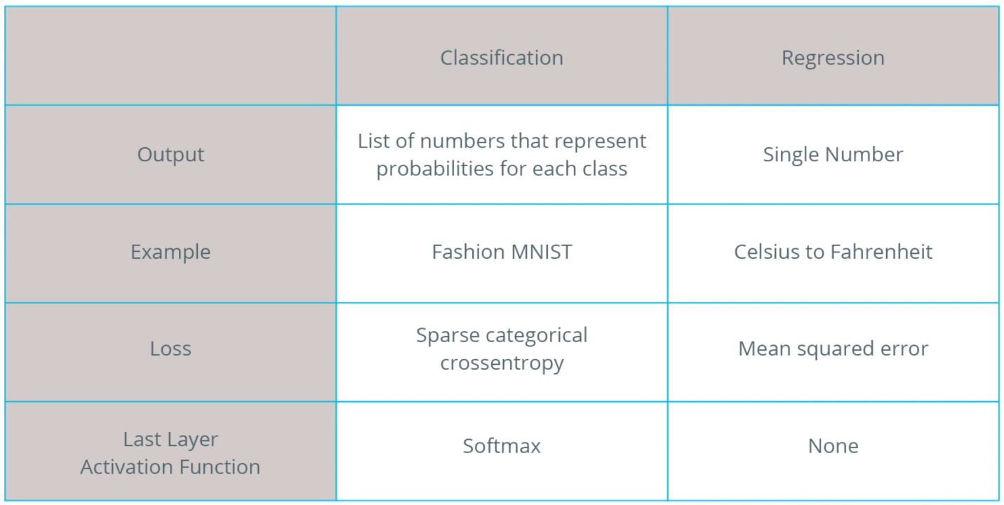

**Convolutional Neural Network**

* A convolution is the process of applying a filter (“kernel”) to an image. Max pooling is the process of reducing the size of the image through downsampling.
* convolutional layers can be added to the neural network model using the Conv2D layer type in Keras.
* This layer is similar to the Dense layer, and has weights and biases that need to be tuned to the right values.
* The Conv2D layer also has kernels (filters) whose values need to be tuned as well.
* So, in a Conv2D layer the **values** inside the **filter matrix** are the **variables** that get tuned in order to produce the right output.
* CNN is mostly used for high dimension image like 1920 x 1820

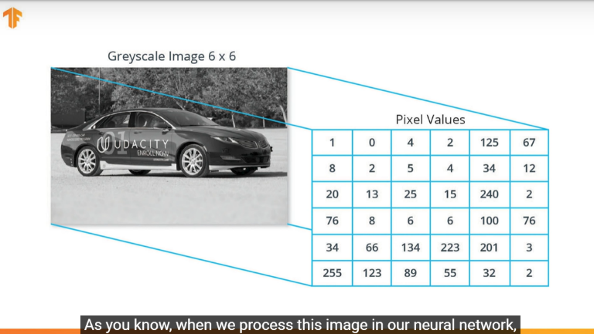 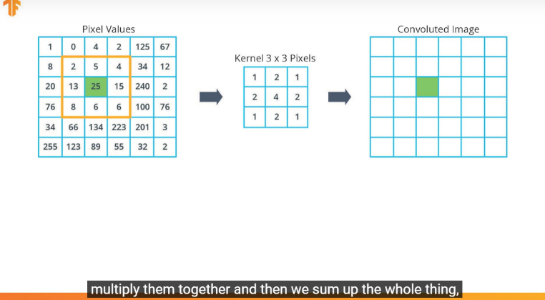

Here are some of terms that were introduced in this lesson:

* **CNNs:** Convolutional neural network. That is, a network which has at least one convolutional layer. A typical CNN also includes other types of layers, such as pooling layers and dense layers
* **Convolution:** The process of applying a kernel (filter) to an image
* **Kernel / filter:** A matrix, which is smaller than the input, used to transform the input into chunks
* **Padding:** Adding pixels of some value, usually 0, around the input image

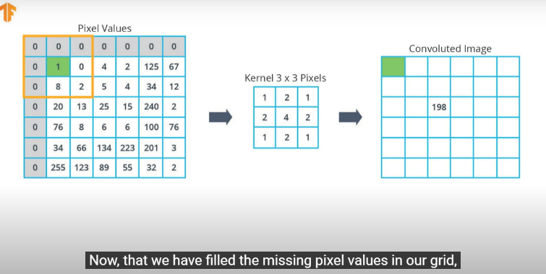

* **Pooling** The process of reducing the size of an image through downsampling. There are several types of pooling layers. For example, average pooling converts many values into a single value by taking the average. However, maxpooling is the most common.

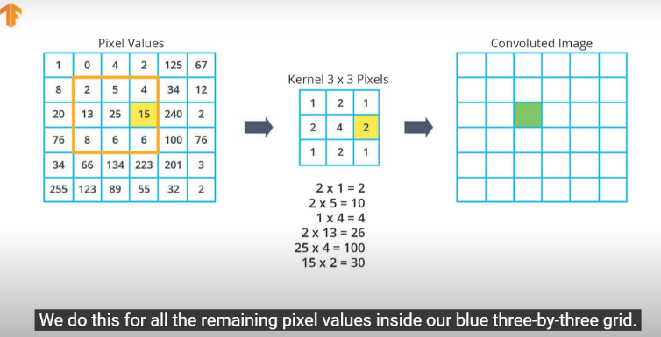

* **Maxpooling**: A pooling process in which many values are converted into a single value by taking the maximum value from among them.

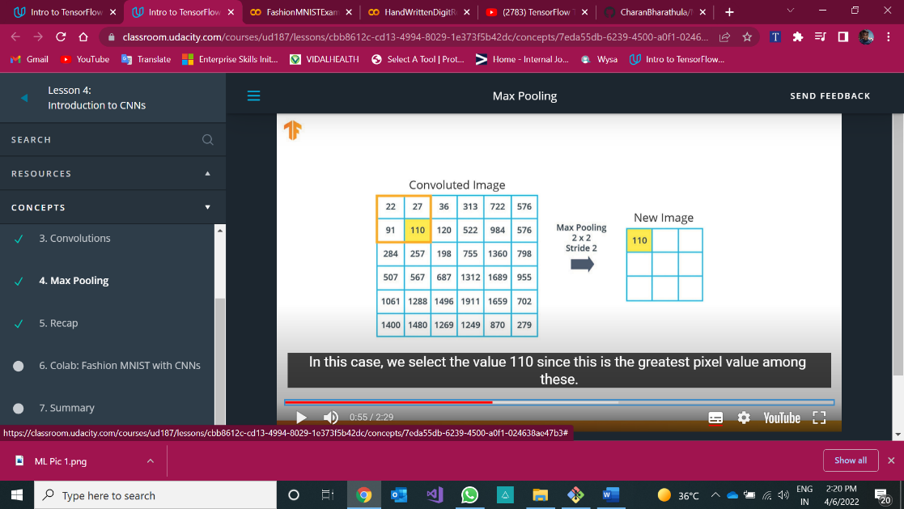

* **Stride:** the number of pixels to slide the kernel (filter) across the image.

In above image, stride was 2. hence 2x2 maxpooling matrix will be moved to 2 pixels to the right

* **Downsampling:** The act of reducing the size of an image

**Note :** The main purpose of Convolution Neural Network is to reduce size of an image using some Maxpooling techniques and pass the reduced images to the remaining layers



**How The Convolved Future Calculated ?**

* For the First element,

1x1 + 1x0 + 1x1 + 0x0 + 1x1 + 1x0 + 0x1 + 0x0 + 1x1 = 4

Same for remaining elements, where Image will be dot product by **Filter Matrix**

* Then ReLu Layer will identifies -ve values from Convolved Future and replace them with zero.
* This process will be repeated till all the features of the image were rectified called as **future map.**
* **Pooling** layer will do downsampling which means it will take nxn matrix of the **future map** and identifies max value of the matrix(ex: 2x2) and replace entire matrix with those values of an image which is used to reduce size of an image. Mostly **MaxPooling** will be used.
* **Finally,** Those future maps will be flattened into 1D array using **Flatten layer**
* Output of **Flatten layer** will be passed to Fully connected Layer like **Dense Layer**

Convoluting a 5x5x1 image with a 3x3x1 kernel to get a 3x3x1 convolved feature

Image Dimensions = 5 (Height) x 5 (Breadth) x 1 (Number of channels, e.g., RGB)

* In the above demonstration, the green section resembles our **5x5x1 input image, I**. The element involved in carrying out the convolution operation in the first part of a Convolutional Layer is called the **Kernel/Filter, K**, represented in the color yellow. We have selected **K as a 3x3x1 matrix .**
* The Kernel shifts 9 times because of **Stride Length = 1 (Non-Strided)**, every time performing a **matrix multiplication operation between K and the portion P of the image** over which the kernel is hovering.

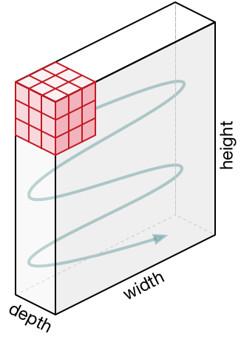

* The filter moves to the right with a certain Stride Value till it parses the complete width. Moving on, it hops down to the beginning (left) of the image with the same Stride Value and repeats the process until the entire image is traversed.



Convolution operation on a MxNx3 image matrix with a 3x3x3 Kernel

In the case of images with multiple channels (e.g. RGB), the Kernel has the same depth as that of the input image. Matrix Multiplication is performed between Kn and In stack ([K1, I1]; [K2, I2]; [K3, I3]) and all the results are summed with the bias to give us a squashed one-depth channel Convoluted Feature Output.



The objective of the Convolution Operation is to **extract the high-level features** such as edges, from the input image. ConvNets need not be limited to only one Convolutional Layer. Conventionally, the first ConvLayer is responsible for capturing the Low-Level features such as edges, color, gradient orientation, etc. With added layers, the architecture adapts to the High-Level features as well, giving us a network which has the wholesome understanding of images in the dataset, similar to how we would.

There are two types of results to the operation — one in which the convolved feature is reduced in dimensionality as compared to the input, and the other in which the dimensionality is either increased or remains the same. This is done by applying **Valid Padding** in case of the former, or **Same Padding** in the case of the latter.



When we augment the 5x5x1 image into a 6x6x1 image and then apply the 3x3x1 kernel over it, we find that the convolved matrix turns out to be of dimensions 5x5x1. Hence the name — **Same Padding**.

On the other hand, if we perform the same operation without padding, we are presented with a matrix which has dimensions of the Kernel (3x3x1) itself — **Valid Padding**.

**How Convolution Neural Network Work on Image Classification?**

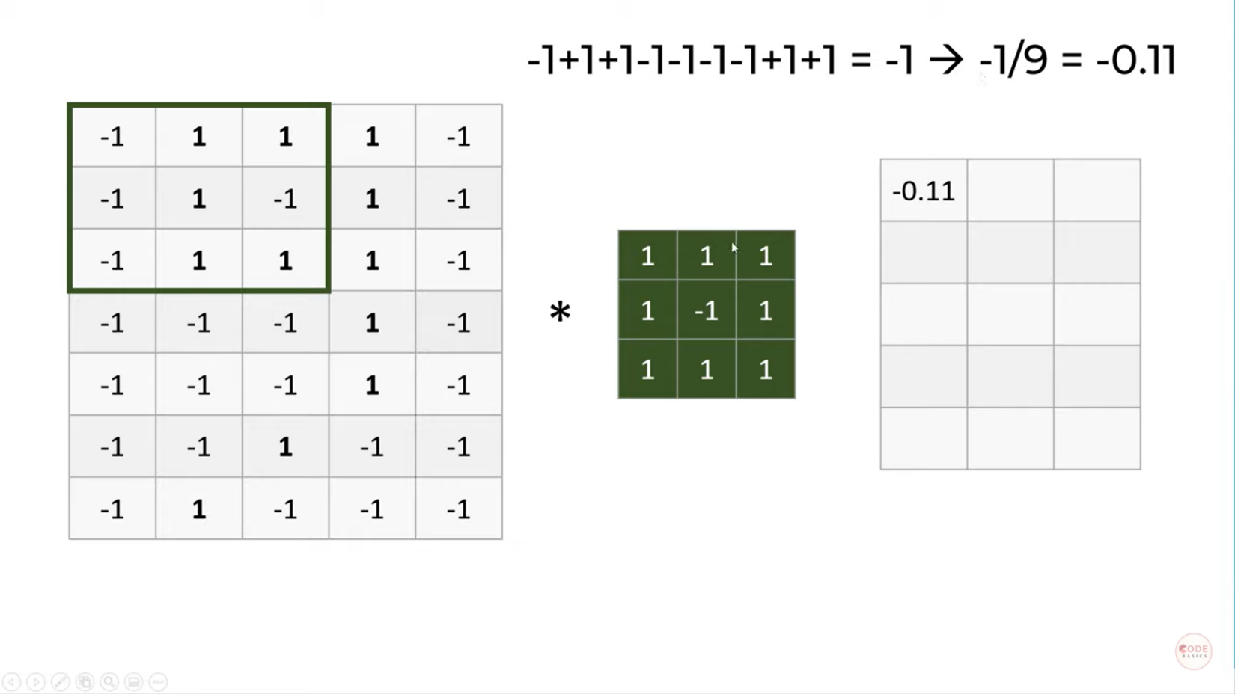

In above Image, left side is the matrix representation of image pixels

We perform 3x3 matrix multiplication with kernel on the middle and output of new image will be calculated. This is called **Convolution operation.**

Here stride will be taken to move that pooling matrix in the input grid

The right hand side grid is called **future map.** Filters are nothing but future detectors.

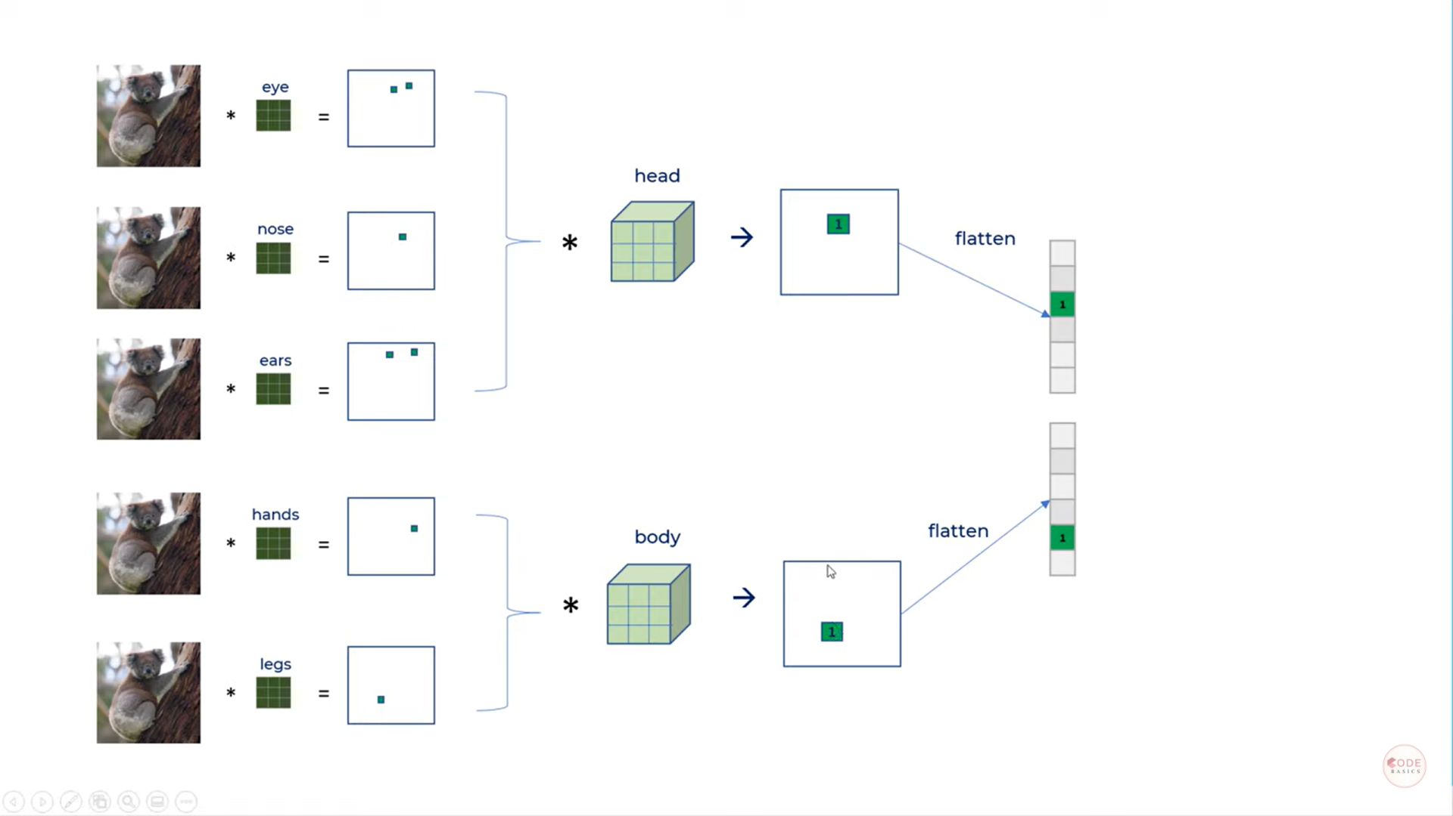

So we iteratively apply **convolution operation** on future maps as well till we find entire image.

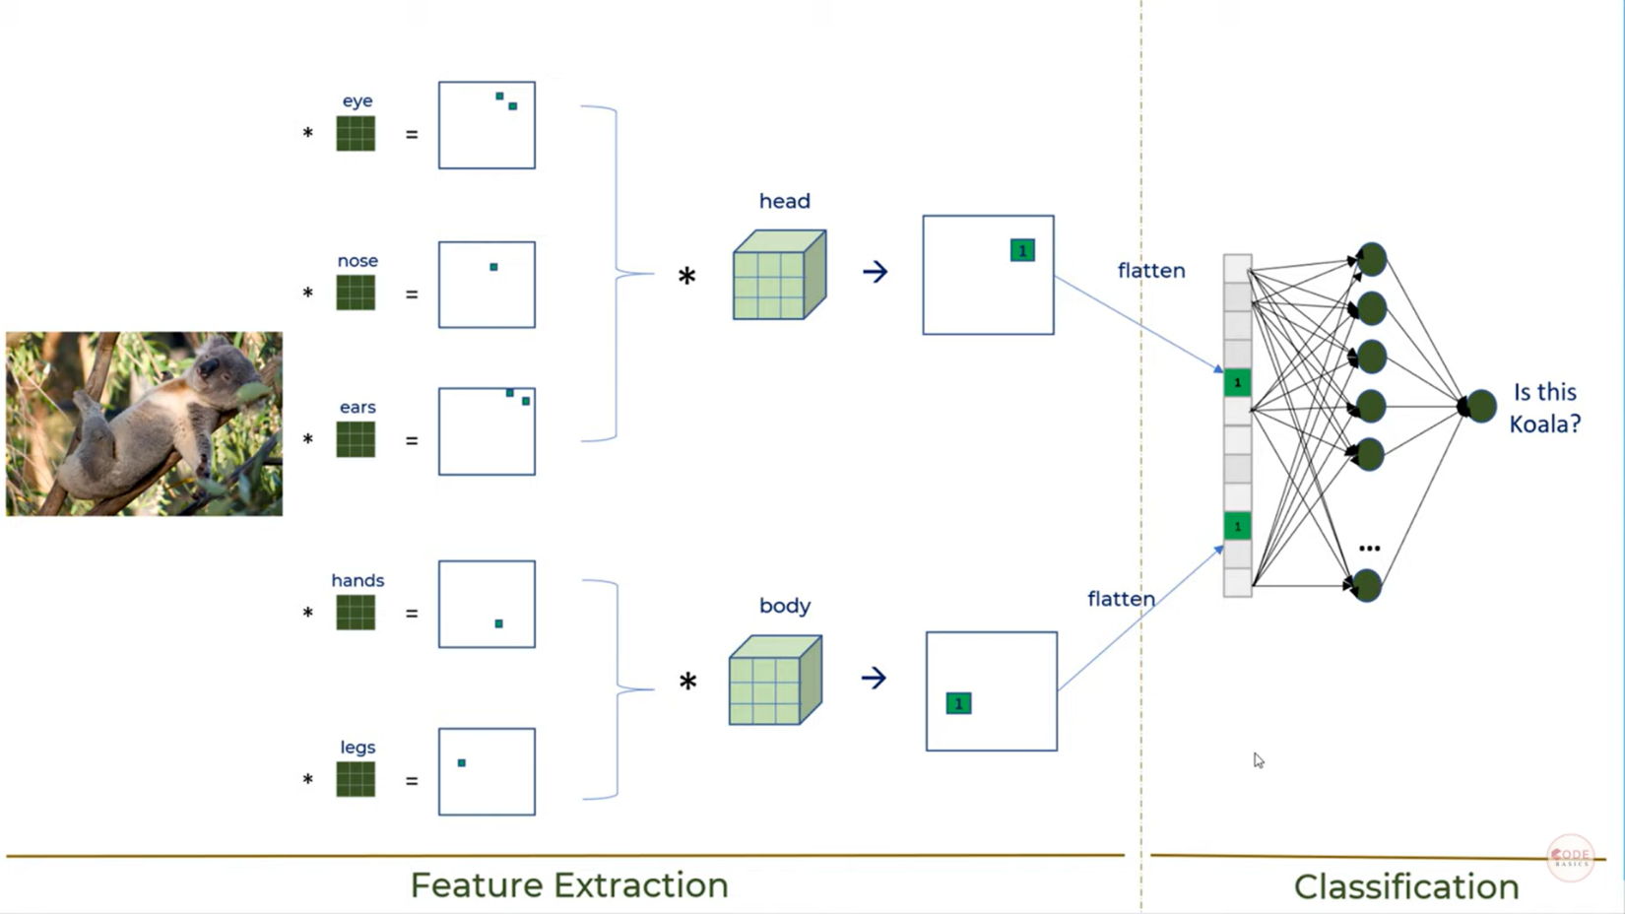

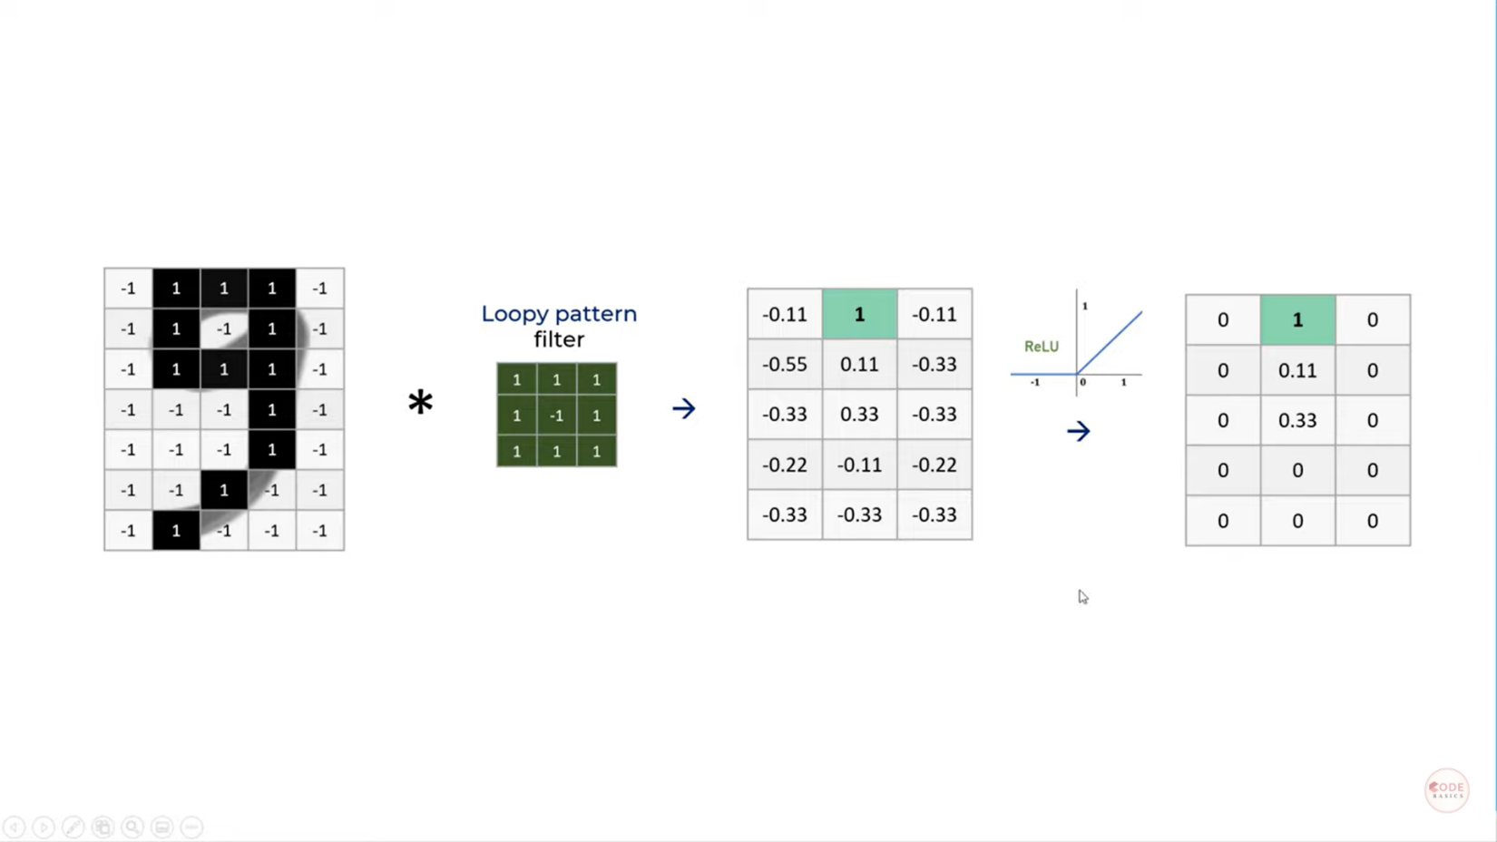

**How CNN Will calculate Convoluted output from input Colored image ?**

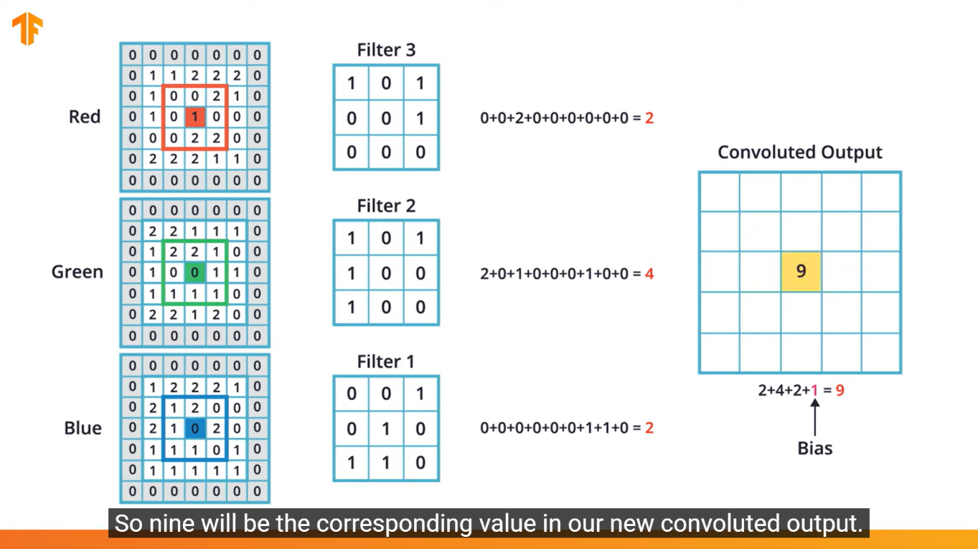

In above example, **one pixel value** for the convoluted output matrix (filter map) was calculated. Similarly, for all the pixels, The **convoluted output** will be calculated. And that is for one 3Dfilter for 3D colored image.

If we use multiple filters, we will get multiple convoluted outputs. Similarly, based on the image size and color channels, we have to perform so many 3D filters.

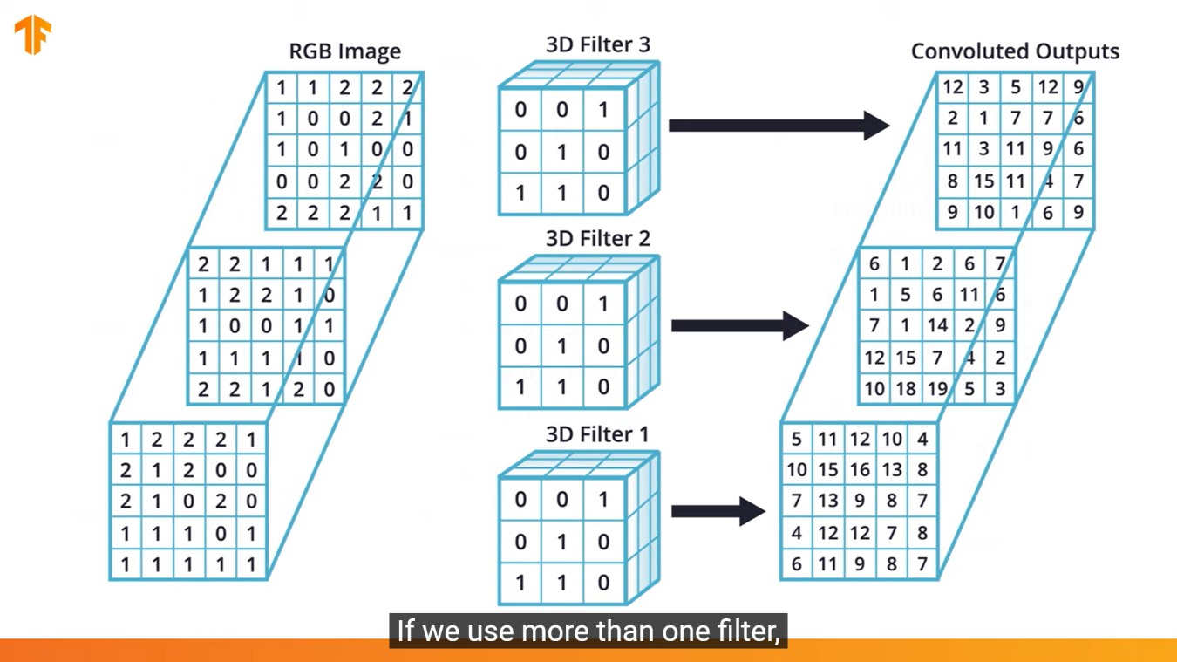

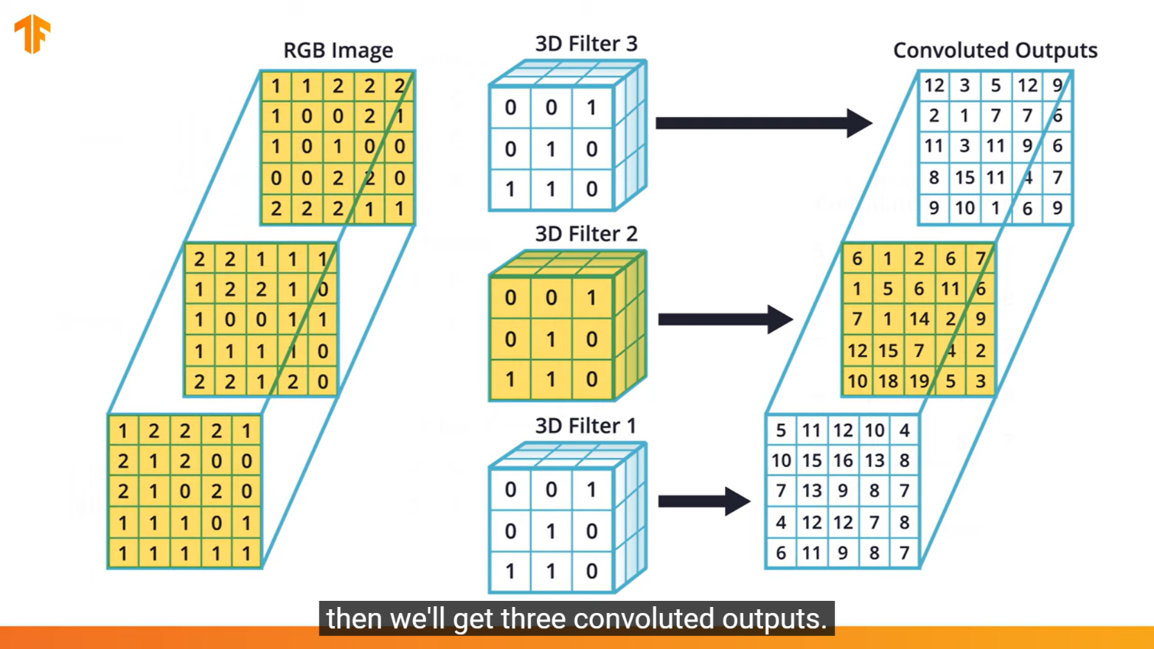

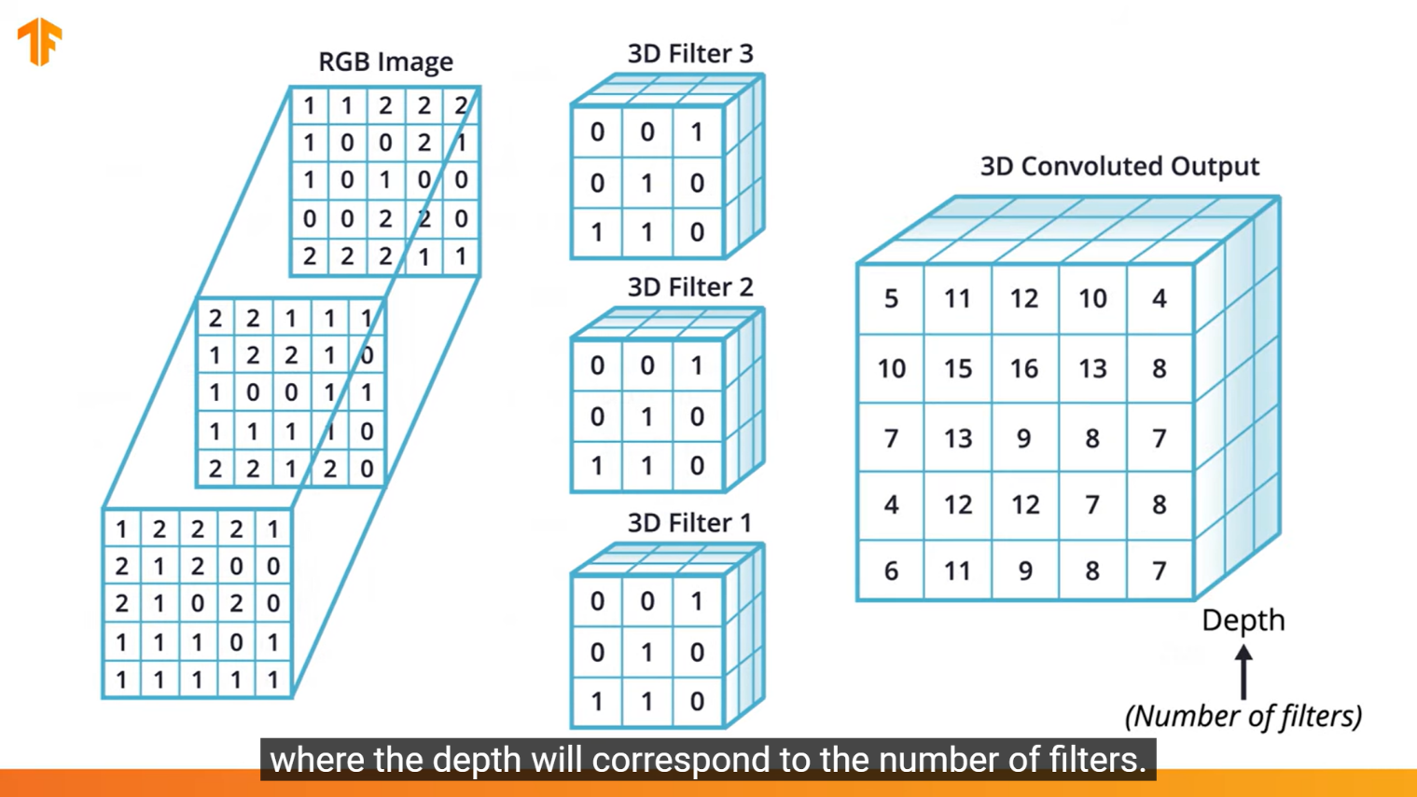

We can control how many Conv2D outputs to be produced in code as

tf.keras.layers.Conv2D(filters, kernel_size, …) : Ex: tf.keras.layers.Conv2D(3, (3,3), …)

**How MaxPooling layer will be applied on 3D Convoluted Output ?**

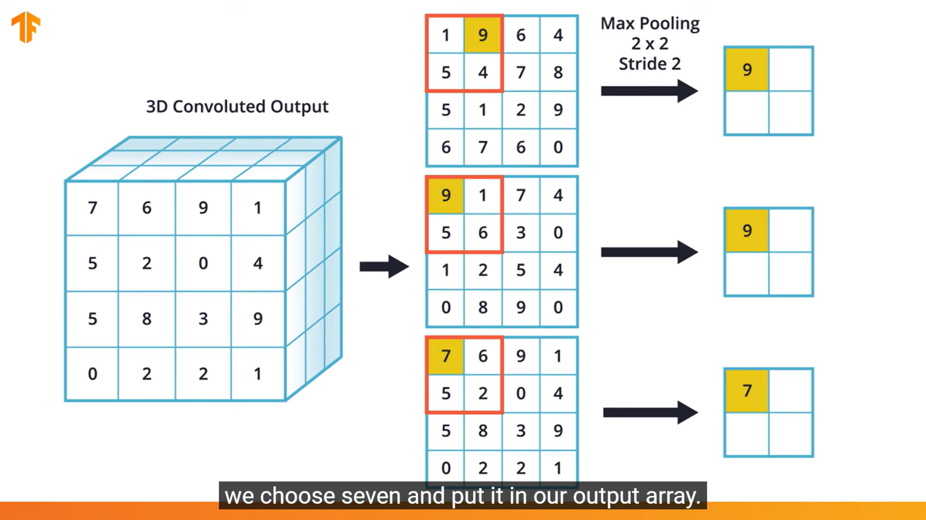

Maximum value of each 2x2 portion of each **2D Convoluted** output will be calculated and will be stored in 2x2 pool matrix finally.

Similarly for remaining 2x2 windows also, max value will be calculated.

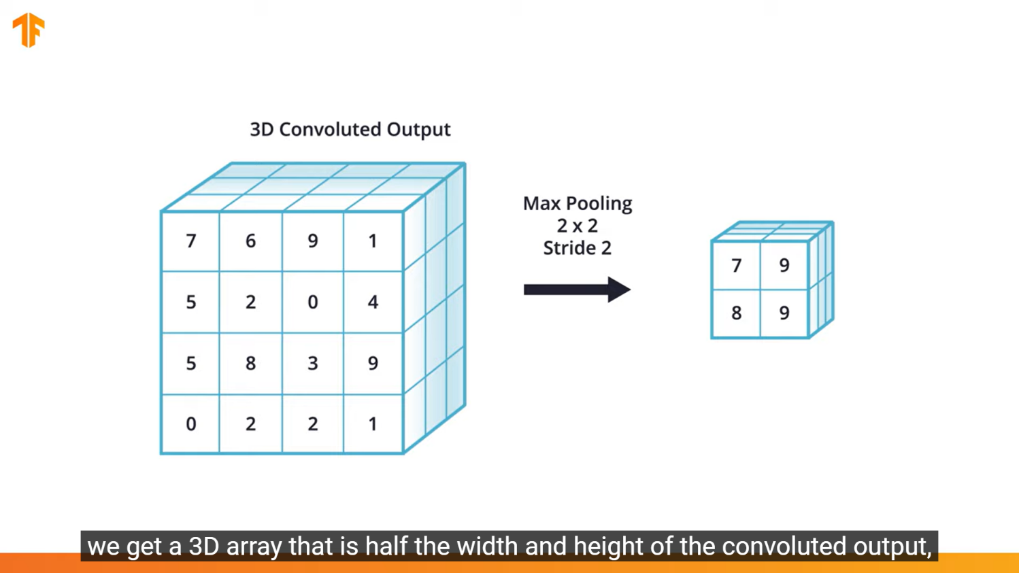

**Simple CNN Model Creation to classify Flower Images**

import tensorflow as tf

import tensorflow_datasets as tfds

from tensorflow import keras

from keras.layers import Conv2D, MaxPooling2D, Dense, Flatten, DropOut

from keras.models import Sequential

import matplotlib.pyplot as plt

import numpy as np

# reading Data

(training_set, testing_set), metadata = tfds.load(‘tf_flowers’, split = [‘train[:70%]’, ‘train[70%:]’], as_supervised =True, with_info=True)

#normalizing data

imgShape = 250

def normalize(image, label):

image = tf.image.resize(image, (imgShape, imgShape)) / 255.0

return image, label

training_batch = training_set.map(normalize). shuffle(len(training_set)//4).

batch(32).prefetch(1)

testing_batch = testing_set.map(normalize).batch(32).prefetch(1)

# Creating Model

num_classes = 5 # Since there are 5 labels in Flower Classification dataset

cnnModel = Sequential([

Conv2D(16, (3,3), input_shape(imgShape, imgShape), activation = ‘relu’),

MaxPooling2D((2,2)),

Conv2D(32, (3,3), activation = ‘relu’),

MaxPooling2D((2,2)),

Conv2D(64, (3,3), activation = ‘relu’),

MaxPooling2D((2,2)),

Conv2D(128, (3,3), activation = ‘relu’),

MaxPooling2D((2,2)),

Flatten(),

DropOut(0.5),

Dense(256, activation = ‘relu’),

Dense(128, activation = ‘relu’),

Dense(64, activation = ‘relu’),

Dense(32, activation = ‘relu’),

Dense(16, activation = ‘relu’),

Dense(num_classes, activation = ‘softmax’),

])

# Model Compilation

cnnModel.compile(

optimizer = ‘adam’,

loss = keras.losses.SparseCategoricalCrossentropy(),

metrics = [‘accuracy’]

)

# Model Training using fit()

cnnModel.fit(training_batch, epochs = 10)

#Model Prediction

image_batch, label_batch = next(iter(training_batch))

image_batch = np.array(image_batch)

label_batch = np.array(label_batch)

predicted_batch = cnnModel.predict(image_batch)

# Comparing Model Prediction with actual labels

class_names = np.array(metadata.features[‘label’].names)

predicted_ids = np.argmax(predicted_batch)

predicted_labels = class_names[predicted_ids]

actual_labels = class_names[label_batch]

print(predicted_labels)

print(actual_labels)

**Natural Language Processing (NLP)**

Natural Language Processing is mostly to analyze sentiment of text of speech

Applications are

* Translate
* Speech Recognition
* Sentiment analysis
* Voice assistants
* Smart Speakers

etc…

**Tokenization:**

The way to represent letters and words in numerical format for input into **CNN**

Neural networks utilize numbers as their inputs, so we need to convert our input text into numbers. Tokenization is the process of assigning numbers to our inputs, but there is more than one way to do this - should each letter have its own numerical token, each word, phrase, etc.

**Embeddings:**

Which is how the neural network will internalize representations of different words

Simple Tokenizer Example

from tensorflow.keras.preprocessing.text import Tokenizer

sentences = [

'My favorite food is ice cream',

    'do you like ice cream too?',

    'My dog likes ice cream!',

    "your favorite flavor of icecream is chocolate",

]

# Optionally set the max number of words to tokenize.

# The out of vocabulary (OOV) token represents words that are not in the index.

# Call fit_on_text() on the tokenizer to generate unique numbers for each word

tokenizer = Tokenizer(num_words = 100, oov_token = “<OOV>”)

tokenizer.fit_on_texts(sentence)

‘’’After you tokenize the text, the tokenizer has a word index that contains key-value pairs for all the words and their numbers.

The word is the key, and the number is the value.

Notice that the OOV token is the first entry.’’’

word_index = tokenizer.word_index

print(word_index)

# Get the number for a given word

print(word_index['favorite'])

After you tokenize the words, the word index contains a unique number for each word. However, the numbers in the word index are not ordered. Words in a sentence have an order. So after tokenizing the words, the next step is to generate sequences for the sentences.

sequences = tokenizer.texts_to_sequences(sentences)

print (sequences)

# **Sequence sentences that contain words that are not in the word index**

Let's take a look at what happens if the sentence being sequenced contains words that are not in the word index.

The Out of Vocabluary (OOV) token is the first entry in the word index. You will see it shows up in the sequences in place of any word that is not in the word index.

sentences2 = ["I like hot chocolate", "My dogs and my hedgehog like kibble but my squirrel prefers grapes and my chickens like ice cream, preferably vanilla"]

sequences2 = tokenizer.texts_to_sequences(sentences2)

print(sequences2)

Reference Link : <https://machinelearningknowledge.ai/keras-tokenizer-tutorial-with-examples-for-fit_on_texts-texts_to_sequences-texts_to_matrix-sequences_to_matrix/>

Even after converting sentences to numerical values, there’s still an issue of providing equal length inputs to our neural networks - not every sentence will be the same length!

There’s two main ways you can process the input sentences to achieve this - padding the shorter sentences with zeroes, and truncating some of the longer sequences to be shorter. In fact, you’ll likely use some combination of these.

With TensorFlow, the pad_sequences function from tf.keras.preprocessing.sequence can be used for both of these tasks. Given a list of sequences, you can specify a maxlen (where any sequences longer than that will be cut shorter), as well as whether to pad and truncate from either the beginning or ending, depending on pre or post settings for the padding and truncating arguments. By default, padding and truncation will happen from the beginning of the sequence, so set these to post if you want it to occur at the end of the sequence.

If you wanted to pad and truncate from the beginning, you could use the following:

padded = pad_sequences(sequences, maxlen=10)

Reference Link : <https://www.tensorflow.org/api_docs/python/tf/keras/preprocessing/sequence/pad_sequences>

Summary of Tokenizer

# Creating Tokenizer

tokenizer = Tokenizer(num_words = 1000, oov_token = “<OOV>”)

# Tokenizing the sentences

tokenizer.fit_on_texts(input_data)

# Converting Input Word indexes into sequences

Sequences = tokenizer.texts_on_sequences(input_data, max_length = optional)

# Padding Sequences

tokenizer.pad_sequences(sequences)

**Embedding**

Embeddings are clusters of vectors in multi-dimensional space, where each vector represents a given word in those dimensions. While it’s difficult for us humans to think in many dimensions, luckily the [TensorFlow Projector](http://projector.tensorflow.org/) makes it fairly easy for us to view these clusters in a 3D projection (later Colabs will generate the necessary files for use with the projection tool).

Reference Link : towardsdatascience.com/why-do-we-use-embeddings-in-nlp-2f20e1b632d2